INDIAS AGRICULUTURAL CROP PRODUCTION ANALYSIS (1997-2021)

* State - Indian state for which record exists
* District - District of specific Indian state in record
* Crop - Crop for which production is recorded
* Year - Year of specific record
* Season - Agriculture season. There are many agriculture seasons in India. One can get more details using this [link](https://studynlearn.com/blog/cropping-seasons/#:~:text=India%20has%20three%20cropping%20seasons%20%E2%80%94%20Rabi%2C%20Kharif%2C%20and%20Zaid.)
* Production - Production count example - 100 KG of wheat produced
* Production Units - Tones (measurement 100 KG = 1 Ton)
* Yeild - Crop yields are the harvested production per unit of harvested area for crop product.

INDEX:

TEAM INTRODUCTION

EMPATHY MAP

BRAINSTORM

ANLAYSIS THE DATA

TEAM INTRODUCTION:

G.MONISHA

TEAM MEMBERS:

S.NIVETHA

E.PACHAMMAL

R.PRITHIGA

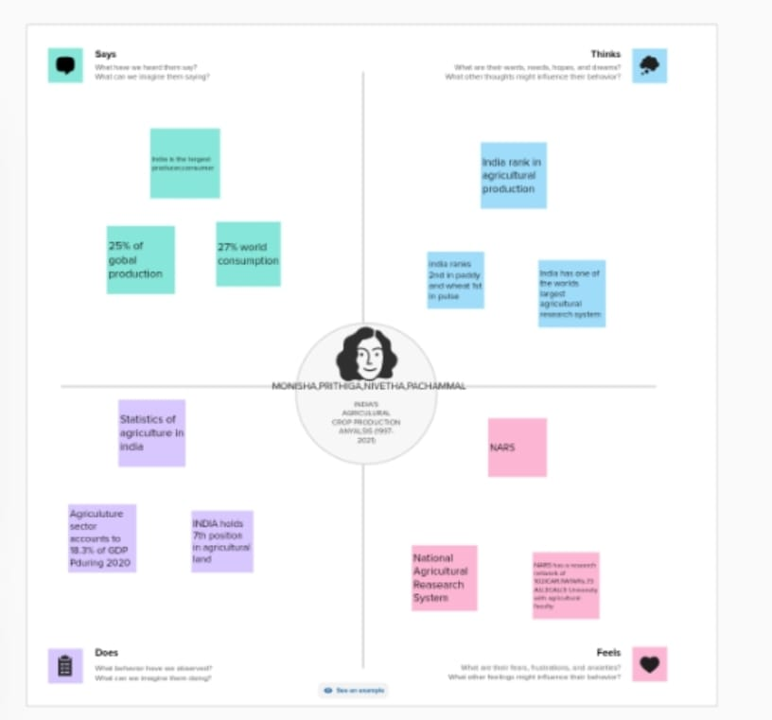

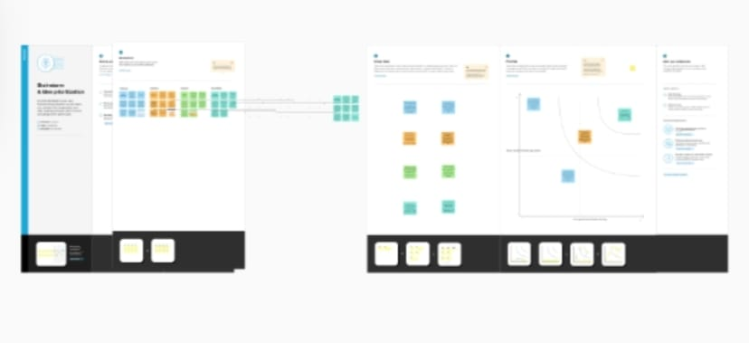

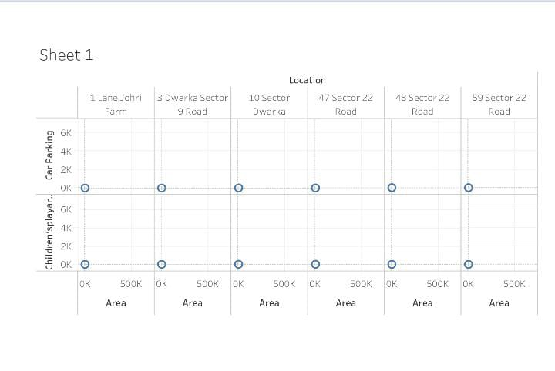

**CONCLUSION**

India's arable land area of 159.7 million hectares (394.6 million acres) is the second largest in the world, after the United States. Its gross irrigated crop area of 82.6 million hectares (215.6 million acres) is the largest in the world.